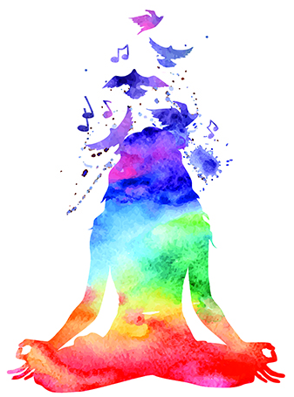
Health, Happiness & Harmony EXPO –

Brought to you by Connect Magazine North Qld

Classes Registration

Cairns – Sunday 5th MAY 2024 9am-4pm

Your Name: _________________________________________________________________
Business Name: _________________________________________________________________
Phone Number/s: ______________________________________________________________
Email: _________________________________________________________________
Facebook: _________________________________________________________________
Website: __________________________________________________________________
Brief description of the CLASS/PERFORMANCE being offered: ___________________________________________________________________________________

____________________________________________________________________________________

Time required (no more than 45mins maximum) _____________Time preference: ___________
Materials required? _______________________________________________________________________

Are you also having an Exhibit?  yes  no
Have you ever advertised or written articles for Connect Magazine?  yes  no
Would you like to be part of our A-ZEN Directory with a year listing for $100  Yes
Do you have Public Liability Insurance:  Yes – please attach 
Please attach a photograph of you and short bio (under 150 words) 
Email to Renee Cashman at: info@connectmagazine.org

