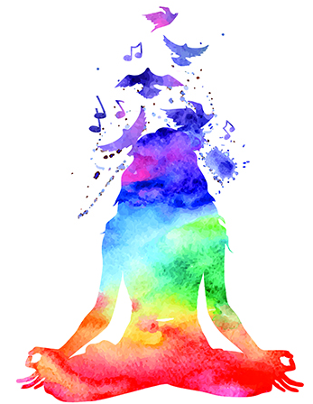
Health, Happiness & Harmony EXPO

-- STALL APPLICATION --

Brought to you by Connect Magazine North Qld

Sunday 5th MAY 2024 9am-4pm

Cairns – The Pier Shopping Centre
Your Name: __________________________________________________________________
Business Name: _________________________________________________________________
Phone Number/s: _________________________________________________________________
Email: _________________________________________________________________
Social Media: _________________________________________________________________
Website: _________________________________________________________________
Brief description of the Service/Therapy/Product being offered at exhibit:
___________________________________________________________________________________

Please note: There are to be NO naked flames or fire hazards of any sort. Exhibitors are encouraged to present their stall in an appealing and creative manner. All stalls are required to bring their own tables, chairs etc. Instructions and a map are sent closer to the event.
Exhibit type: Small: 2.4m W x 1.8m D $45 (1 x trestle table) ____________________
(site fee only): Medium: 2.4m W x 2.4m D $65 ___________________________________
Large: 3m W x 3m D $85 ___________________________________
Limited sites have power available +$10  yes

Would you like to donate a complementary treatment or product to be used as a Random Gift of Kindness to be given away during The EXPO? A Random Act of Kindness bag will be delivered to you on the day so that you can add your Voucher or product and give away.
 Yes: Please describe __ __________________________________________________
___________________________________________________________________________________

Do you have Public Liability Insurance:  Yes – please attach 

